 | 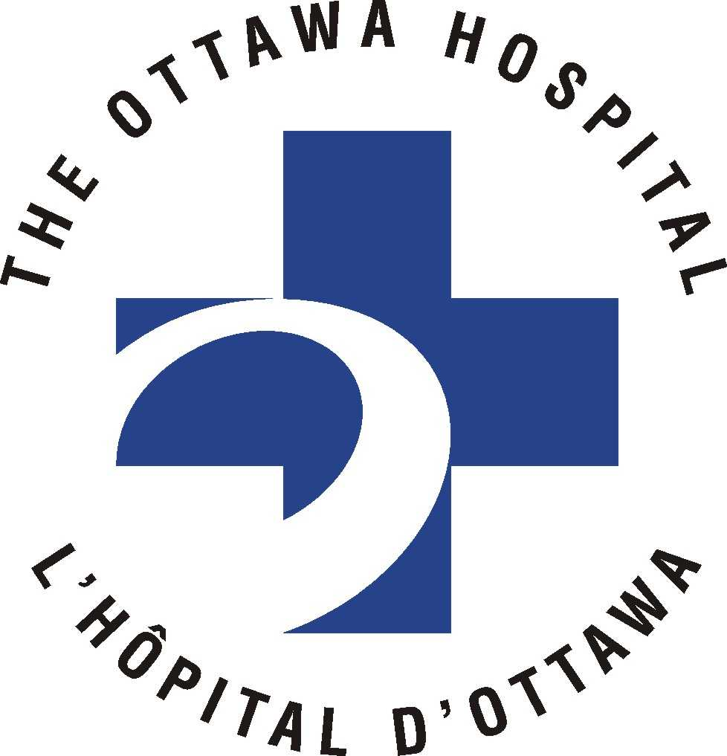
Ottawa Hospital Research Ethics Boards / Conseils d’éthique en recherches

Civic Box 411 725 Parkdale Avenue, Ottawa, Ontario K1Y 4E9 613-798-5555 ext. 14902 Fax : 613-761-4311
http://www.ohri.ca/ohreb

ANNUAL RENEWAL REPORT
1. REPORT DATE:
2a. Protocol Number:
2b. Protocol Title:
3. Principal Investigator
at The Ottawa Hospital:
4a. Co-Investigators:
4b. Have any co-investigators been added or removed since the last approval? Yes No
If new investigators have been added, include a letter or Amendment Report with the Additional Co-Investigator page http://www.ohri.ca/ohreb/forms/additional_co.doc with their original signature.
5a. Most recent approval ‘expiry date’:
5b. Number of research participants who have provided consent AND enrolled into the study locally, since initial approval (if this is the first renewal for this study) OR last renewal report date (if this is the 2nd/subsequent renewal for this study) :
5c. Total number of research participants who have provided consent AND enrolled at this site since initial OHREB approval (if this number exceeds the currently approved sample size, then refer to Section 7):
5d. Number of local withdrawals since initial OHREB approval (if this is the first renewal for this study) OR last renewal report date (if this is the 2nd/subsequent renewal for this study):
5e. Total number of withdrawals at this site since initial OHREB approval:
5f. Reason for withdrawals:
6. Projected date of study completion (this should reflect the information provided in the initial application and/or the information provided in Section 7)

ANSWER ALL OF THE FOLLOWING QUESTIONS:

7a. Yes No Has there been a departure from previously approved research. If yes, please specify:
- Completion date change/sample size increase Yes No
or decrease?
- Inclusion/exclusion criteria? Yes No
- Source of subject (participant) population? Yes No
- Source of volunteer population (if applicable)? Yes No
- Other? Describe: Yes No

7b. Yes No An amendment form has been submitted to the OHREB for review of any of the
above changes?
If yes, date approved:

7c. Yes No Have any unexpected side effects, adverse events, or findings been noted since last approval? Has the OHREB been informed of these?
Yes No If yes, date submitted:

7d. Yes No Has any information appeared in the literature, or evolved from this or other similar ongoing studies, since the date of last approval that might affect the OHREB’s or the research participant’s perception of the risks and benefits of the study? (If yes, provide this information and your assessment of it in the section on progress of the study). Has the OHREB been informed of these? Yes No If yes, date submitted:

7e. Yes No Has the consent form been modified since last approval? Has the OHREB been informed of these changes? Yes No If yes, date approved:

7f. Yes No WRITTEN INFORMED CONSENT has been obtained and will continue to be obtained from all research participants, or their next-of-kin/legal representative.
NOTE:

Attach an ORIGINAL COPY of the most recently APPROVED consent forms, if no changes have been made. (If recruitment is closed, the OHREB does not require a copy of the consent form)

If the Patient Information Sheets and/or Consent Forms are being revised, attach a copy of the revised documents with ALL CHANGES HIGHLIGHTED; and a clean, final version of the revised documents printed ON ORIGINAL LETTERHEAD.

Consent Forms and the study are approved for a maximum duration of one year only and must be validated by the board annually.

8. In the space below, briefly describe the progress of the study to date. Renewals cannot be considered if this section is not complete.
PLEASE TYPE OR PRINT CLEARLY

Original Signature of Principal Investigator Date

PLEASE NOTE: You must keep a copy of this form for your study file.

